|  |  |
| --- | --- |
| **Test Name** | Check out – Use case Test |
| **Use Case Tested:** | Check Out |
| **Test Description:** | When the guest wants to check out from the Hotel, System will charge for the services which have been availed by the Guest. The system will ask the user to enter the room id and enter the cost of the service. The system will display the services amount only $0.0. When the user enters the card details, not any amount has been deduced from the card. |
| **Pre-Conditions:** | The Hotel Reservation System main menu is displayed to the user. |
| **Post-Conditions** | **Normal Flow and Alternative Flow**   1. System will ask for the Room-Id. 2. Services charges will be displayed. 3. System will ask for the Card details. 4. Amount has been successfully debited from the account.   **Unsuccessful Scenario**   1. Booking not found for the specified room id. 2. Services charges are not deduced. |
| **Notes:** | The Flow of the Check out is correct |
| **Results (Pass / Fail/Warning/ Incomplete)** | Pass |

|  |  |  |  |  |
| --- | --- | --- | --- | --- |
|  | **TEST STEP** | **EXPECTED TEST RESULT** | **P** | **F** |
| 1. | Prompt the user to enter room number | Enter Room Number | **✓** |  |
| 2. | Enter Room Number | Display the Invoice | **✓** |  |
| 3. | Display the Invoice | Prompt the user to accept charges | **✓** |  |
| 4. | Prompt for accept the charges | User accept the charges | **✓** |  |
| 5. | Accept the charges | Prompt the user to enter credit card | **✓** |  |
| 6. | Prompt to enter credit card | Enter Credit card type | **✓** |  |
| 7. | Enter Credit card type | Prompt for credit card number and CCV | **✓** |  |
| 8. | Prompt for credit card number and CCV | Display the debit message | **✓** |  |
| 9. | Display the debit message | Enter Continue | **✓** |  |

**Test Data Table**

|  |  |  |  |  |  |
| --- | --- | --- | --- | --- | --- |
| Variables | Room type/room number | Charges Accept | Credit Card Type | Credit Card Numer | CCV |
| 1. | Single / 101 | Y | V | 1 | 1 |

Screenshot

**The Hotel Management System main menu is displayed**

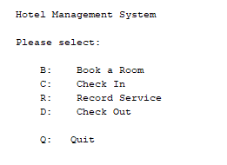

**Select B to Book a room**

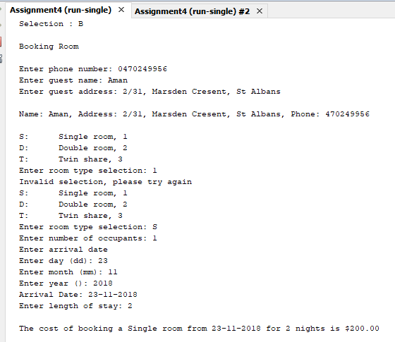

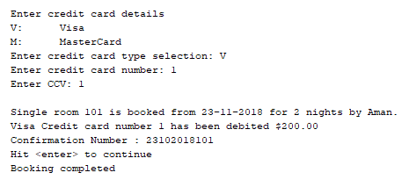

**Check in**

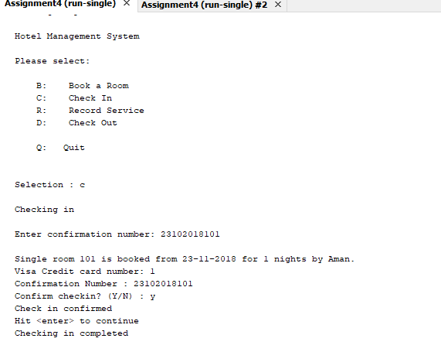

**Services**

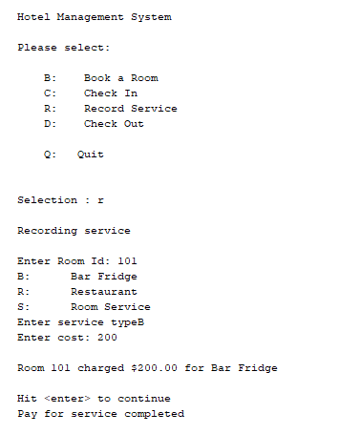

**Check Out**

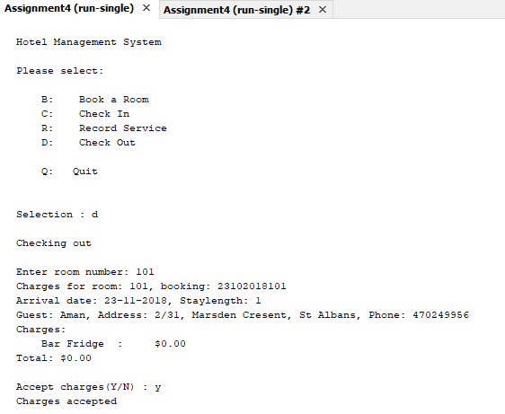

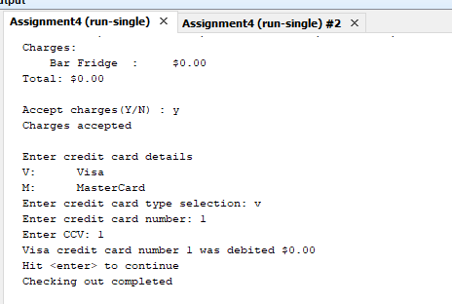

**The charges for the Bar Service is $200. But it is showing the $0.00 in the invoice.**